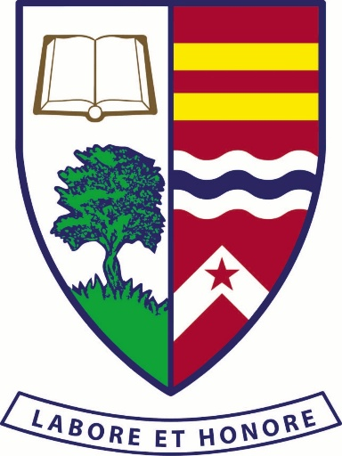

IGS Holiday Cricket Clinics are open to Ipswich Grammar School students and friends of all standards currently in Prep to Year 11. The date for the next Clinic is yet to be determined.

